Terminal Services and the Printing Redirection Process

August 2001

Statement of Confidentiality
This document contains information, which may relate to the trade secrets of MC³ Digital Solutions, or those of its suppliers, as well as financial, commercial, scientific, or technical information that is confidential to MC³. Disclosure of such information may result in material or financial loss, or may prejudice the competitive position of MC³ and its suppliers. Accordingly, such information shall not be disclosed except to the employees of MC³ for the purpose of evaluation of this document.
Table of Contents

Printing redirection under RDP5 3
Introduction 3
How it works 3
Workstation Setup 3
Windows 9X/ME Clients 4
Windows NT/2000 Clients 6
Server Setup 8

Printing redirection under RDP5

Introduction

Back in 1998, Microsoft released Windows NT Server, Terminal Server Edition (TSE), at that time known as ‘Hydra’ during its beta test process. This was the first Multi-user Windows NT product based on the new Windows NT 4.0 technology. Under a Microsoft license, another company, Citrix, had a product based on Windows NT 3.51, called WinFrame and when Microsoft released TSE, a new add-on for it was released: Citrix MetaFrame 1.0.

Citrix always used ICA as their remote desktop protocol on their Windows NT based products. With TSE, Microsoft introduced a new protocol, RDP and when compared to ICA, many features were missing.

On February 2000, Microsoft released its new corporate OS, Windows 2000 and now Terminal Server was not a separate product but a service that you could enable or disable at anytime. Many improvements were made and of course a revised RDP came out. RDP 5.

Many features were added to it and this white paper covers one of the most important ones in the corporate world: printing redirection. This document covers how this process works and all the steps you need to follow in order to have this feature working on Windows machines (Windows 3.X/9X/ME/NT/2000) running as Terminal Services Clients.

How it works

The whole process is quite simple. When a client connects to the Windows 2000 Server running Terminal Services, the server checks for the client printer connected to the client’s local port and if the server supports it, it creates a local printer within the session named PrinterDriverName/UserName/Session_Number.

During this process, the printer will not be created if:

- The printer is not connected to the client local port (like a networked printer).
- The printer is not supported or recognized by default under Windows 2000 (remember that the server needs to recognize the printer in order to create it locally within the session).

Let’s take a look at how these issues can be solved.

Workstation Setup

The steps here are almost identical for all the Operating Systems supported as Terminal Services clients, with local or networked printers attached to them.

You can use native (installed by default with any of these Operating Systems) or manufacturer supplied drivers on the workstation side. The end result will be exactly the same.

First, install the printer as if it were connected to the local LPT1 port even if the printer is installed in a different machine and therefore, it will be accessed as a network resource. Some drivers (like HP) will test if the printer is connected to the port or not. Ignore such tests or errors when installing such drivers.

If the printer is local, the workstation setup is done. If it is a network printer an extra step is required and this is different for Windows 9X/ME and Windows NT/2000 machines.

Windows 9X/ME Clients

Open Control Panel and then Printers. Your new installed printer should be there. Right click it and click ‘Set as Default’ (Fig. 1).

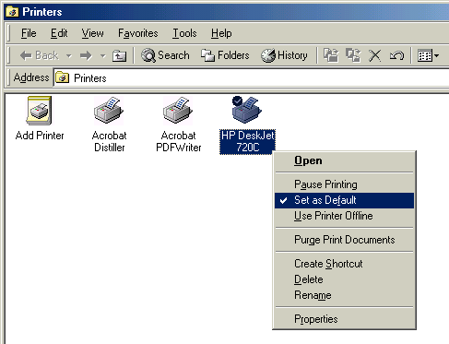

Fig.1

Now right-click the printer and click ‘Properties’. You will see the printer properties (Fig. 2). This will be a little bit different from printer to printer and depending on the drivers you used to install your printer.

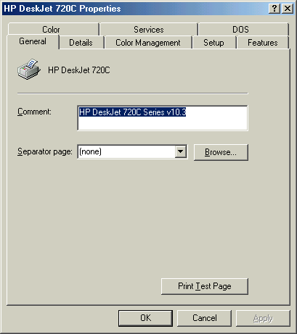

Fig.2

Click on the ‘Details’ tab and make sure the printer is installed as if it were connect to LPT1: (‘Print to the following port’ must show LPT1), otherwise printing redirection will not work (Fig. 3).

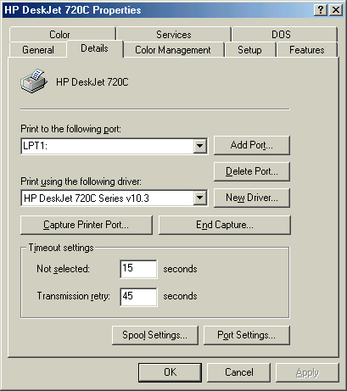

Fig.3

Now click on the ‘Capture Printer Port…’ button and type in the UNC for your network resource (Fig. 4). Make sure ‘Reconnect at logon’ is checked in order to have this printer mapped every time you logon to your computer.

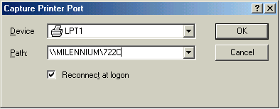

Fig.4

Windows NT/2000 Clients

In this case the process is a little bit different but it follows the same concept as for Windows 9X clients. Open Control Panel and then Printers. Your new installed printer should be there. Right click it and click ‘Set as Default’ on NT4 or ‘Set as Default Printer’ on Windows 2000 (Fig. 5).

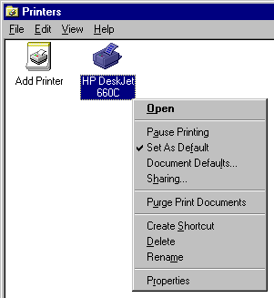

Fig.5

Now, right click the printer and select ‘Properties’. You will see the printer properties (Fig. 6). As explained for the Windows 9X/ME workstations, this will be a little bit different from printer to printer and depending on the drivers you used to install your printer. The Windows 2000 screen will be slightly different too.

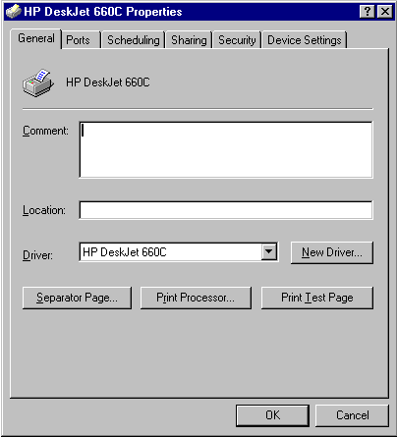

Fig.6

Now, as this printer is installed under a Windows NT/2000 machine, we have different properties for it. Click on the ‘Ports’ tab and make sure your printer is connected to a local port, in this case LPT1 (Fig.7).

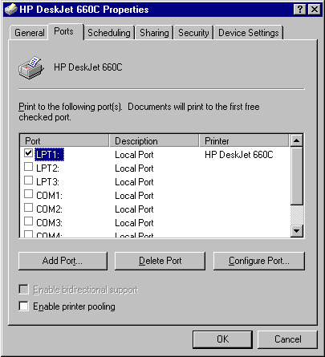

Fig.7

Now only one final step is required. Open a command prompt window and create a file named PRNTMAP.CMD and on this file you will add the following line:

NET USE LPT1: \\SERVER\SHARED_PRINTER /PERSISTENT:YES

Where SERVER is the name or IP address of the server that is sharing the printer. SHARED_PRINTER is the shared printer itself as named on the server. Add this file to the startup folder of your Windows NT/2000 workstation or in a login script for users, so every time they logon to their workstations, they will have the printer local port mapped to a shared resource on the network.

Server Setup

If the printer is not supported by default on the Windows 2000 Server running Terminal Services, you will have to edit the NTPRINT.INF file under \WINNT\INF. The first thing that you need is the exact printer driver name that your printer is using on the workstation. To get this information, take a look at Fig. 3 or Fig. 6 (depending on your client OS) and write down the exact name that appears under ‘Print using the following driver’ or ‘Driver’ (Windows 2000/NT Clients). This is the name we will need to insert on the NTPRINT.INF file under the [Previous Names] section.

For example, one user has a Deskjet 722C installed using "HP DeskJet 720C Series v10.3" as the main driver (Fig.3). With this information, open the file NTPRINT.INF and look for [Previous Names]. Now add a line like this on this section:

"HP DeskJet 722C" = "HP DeskJet 720C Series v10.3"

As you can see the left column is the printer driver or name that Windows 2000 recognizes (to see which ones work, just try to add a printer to the server and check the Printer names you see on the right side under ‘Printers’ – Fig.8). The right column on the NTPRINT.INF file is the driver name under your LOCAL Machine.

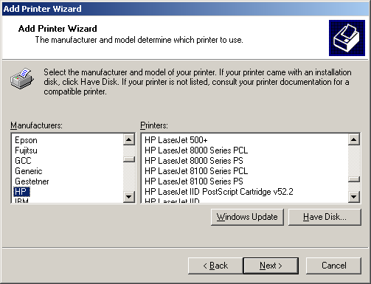

Fig.8

Remember that for each different printer without direct support by Windows 2000, we will need to add a line like that to the NTPRINT.INF file. However we could install the printer driver on the Terminal Servers but this procedure is not recommended, as it is the main cause on BSOD under Terminal Services environments. We will need to find an alternative driver for all these printers that is supported on Windows 2000 by default.

DOS Printing

Many customers still need support for DOS applications running on the Terminal Server. Of course this works but an extra and simple step is required. After you opened a session with the Terminal Server and got your local printer mapped, you will need to go to Start | Settings | Printers (Fig.9).

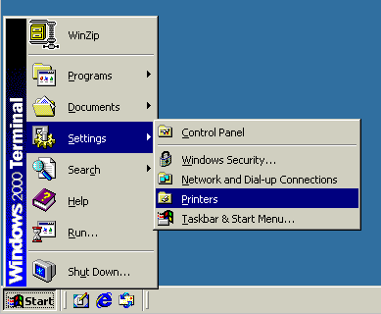

Fig.9

Your mapped printer should be the default one (Fig.10).

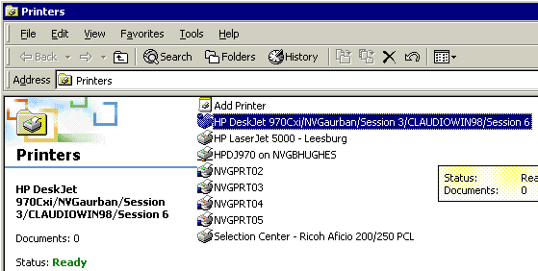

Fig.10
Now, right click this printer and select ‘Properties’ (Fig.11).

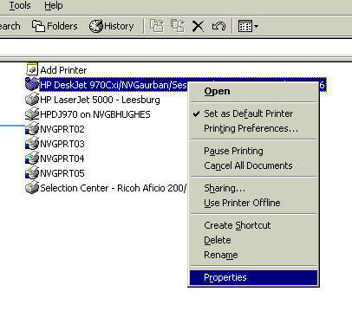

Fig.11

The Printer properties screen will show up. Click on the ‘Sharing’ tab and share it as DOS (you can give any name. In this example I used DOS) and click on ‘OK’ (Fig.12).

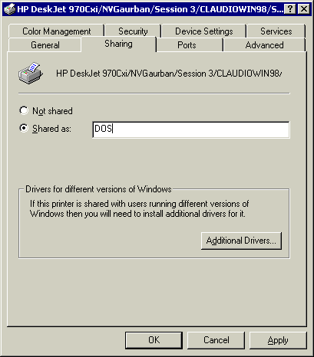

Fig.12
This portion is done. Now you need to capture the LPT1 port under your session and map it to this new printer. Open a command prompt window and type NET USE LPT1: \\YOUR_SERVER_NAME\DOS (or the name you gave to the shared printer).
After this, all jobs printed through DOS applications that print to the LPT1 port will be printed on your local printer connected to your PC.
Again, remember that these steps are performed within your session, therefore on the server side and not on the client.
You can write a script using KIXTART or even VBS to share your created printer (as it changes its name every time you connect) and map it to the LPT1 port. This will automate the whole process to the user and make it transparent.

If you have any comments or questions about this article, please contact Cláudio Rodrigues (Claudio_Rodrigues@Terminal-Services.NET or Claudio.Rodrigues@MC3DS.NET) .

Cláudio Rodrigues, is a Senior Server-based Computing Architect, and has been involved in integrating various technologies for over 11 years in Brazil, the United States, and Canada. Claudio is a Microsoft Certified Professional ("MCP"), Citrix Certified Administrator ("CCA") and Certified Netware Engineer ("CNE") with extensive experience in working with Compaq, Microsoft, Novell and Unix products and has been working with server based computing in multi-platform environments since 1996 with large-scale enterprise clients.

