- First they arrest Moh'd Saleh, a Plastinian aged 23. So far nothing is wrong with the picture

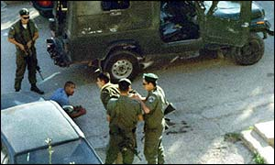

- Then they pin Moh'd on the floor suspecting he had bombs attached to him. Still nothing out of the ordinary?

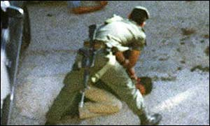

- They have him on the floor still, and they try to question a second Plastinian on the scence. They seem to have definitly overpowerd him and have full control over the suitation.
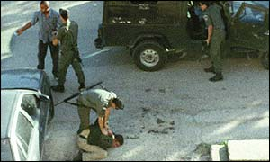
- That's not enough? OK!! Now they have to strip him to make sure he doesn't really have any bombs on him. AS we can see he is almost naked on the floor, (at least they had the decency to keep his underwear on), he is obviously overpowerd and unarmed, there is no sign of a bomb or any resistant. So what would a democratic country such as Isreal, a county which claims to respect human digintiy and life do??? Take him to prison?? 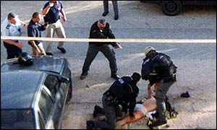
- The picture speaks for itself !?!

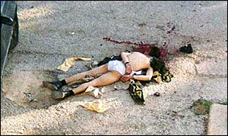

The least you can while sitting in the comfort of your home is forward this file to as many people as possible espically westerns so they can have a glimse of what Plastinians go through!!

