Compaq OpenVMS

and

Digital Networks

OpenVMS Cluster Environment
Test Report

August 14, 2001

Alan Boyles

Senior Systems Engineer

Digital Networks

Andover, MA

aboyles@dnpg.com

Executive Summary

Tests were conducted on Digital Networks DNmultilayer 1200 and DNswitch 800 to determine viability in an OpenVMS Cluster environment

Test hardware included a 4 node OpenVMS Cluster of AlphaServer GS series nodes each with 4 – EV68 CPU’s.

Test software environment was OpenVMS Version 7.3 with OpenVMS Cluster and Host Based Volume Shadowing (HBVS) for OpenVMS.

Test scenario included configuring a 4-node cluster, 2 nodes with direct access to storage and 2 nodes with MSCP (Mass Storage Control Protocol) served access. Each switch was utilized as the Cluster Interconnect.

Tests proved that each switch would work in an OpenVMS Cluster environment.

Tests proved a significant performance improvement when utilizing Gigabit Ethernet as the Cluster Interconnect.

Additional feasibility study was done on the Digital Networks GIGAswitch/FDDI system to the Digital Networks VNswitch with Gigabit Ethernet capability.

This study proved a viable upgrade capability from the GIGAswitch/FDDI system using the VNswitch 900 GV module.

Test Objectives

Testing of the Digital Networks DNswitch 800 and the DNmultilayer 1200 took place during the week of July 22, 2001 at the Compaq Computer Corporation VMS test lab in Nashua, NH. These tests were conducted to test the viability and performance of the 2 switches in an OpenVMS Cluster environment. In a secondary test, Digital Networks tested what is considered to be a standard legacy environment utilizing a Digital Networks GIGAswitch/FDDI system and a MultiSwitch 900 with VNswitch options to test an FDDI to Gigabit Ethernet OpenVMS Cluster. A more detailed explanation is at the end of this report.

Test Scenario

The Test Suite hardware consisted of 1 AlphaServer GS160 with 16 EV68 CPU’s (1000 Mhz ), 64 gigabytes main memory, 4 PCI boxes, 2 KGPSA disk controllers, 4 HSG60 controllers, 26 18 and 36 gigabyte disk drives, 4 DE602-AA 10/100 Ethernet controllers, and 4 DEGPA-SA Gigabit Ethernet controllers.

The Test suite hardware was configured in 4 hard partitions consisting of 1 Quad Building Block (QBB) with 4 EV68 CPU’s, 16 gigabytes of memory, 1 PCI box, and 1 DE602-AA Ethernet controller. Two of the hard partitions had KGPSA disk controllers and 2 did not. This configuration was designed to cause I/O’s to be MSCP served through one of the partitions thereby increasing the load on the switch being tested.

The Test Suite Software environment consisted of Compaq OpenVMS Version 7.3 including OpenVMS Cluster software and OpenVMS Host Based Volume Shadowing software.

The Test suite hardware was configured with OpenVMS running from a single shadowed system disk attached to the HSG80 controllers. Since only 2 instances of the test hardware had direct access to the HSG controllers and to the system disk the other 2 instances connected to the system disk using the Local Area Network ( LAN ) connection, which was the Digital Networks switch products under test at the time.

Digital Networks Test Equipment

Tests were conducted on 2 Digital Networks switches, the DNMultilayer 1200 configured with 16 - TX 10/100 Ethernet connections, and 3 - Gigabit (1000 BASE SX) connections, and the DNswitch 800 with 8 Gigabit (1000 BASE SX) Ethernet connections. After the completion of these tests some additional legacy equipment was tested. A GIGAswitch/FDDI system and a MultiSwitch 900 were setup to test upgrade scenarios from FDDI based OpenVMS clusters to Gigabit Ethernet. The MultiSwitch 900 consisted of 5 modules, 1 – 916TXG, 1- VNswitch 900EF, 1 – VNswitch 900FX, 1 - DECConcentrator 900MX, and 1-VNswitch 900GV.

The DNmultilayer and DNswitch families each utilize a common hardware and software base across all members of the product families. Therefore, this testing is representative of all members of the DNmultilayer and DNswitch product families.

Test Plan

The test plan was to incrementally test the Digital Networks switches to determine if they would work successfully in an OpenVMS cluster environment without any serious performance bottlenecks for cluster LAN traffic. The DNmultilayer 1200 can perform at both speeds of 10/100 Mbs and at Gigabit speeds so the initial test was done on this switch to determine viability and the performance differential. The 1200 test consisted of creating a 2 node OpenVMS Cluster running a 100 Mbs LAN interconnect, each node with direct access to disk subsystem, then add the 2 additional remaining nodes in succession with a 100 Mbs LAN connection, having Mass Storage Control Protocol (MSCP) access to the storage subsystem. MSCP connection to disk means that the serving nodes must perform intervention tasks on behalf of the served nodes. This utilizes CPU and network bandwidth. Tests run on the OpenVMS cluster consisted of normal cluster boot activities such as cluster configuration and setup, as well as, shadowed disk setup and merge copies. In addition, numerous disk-to-disk transfers using VMS COPY and BACKUP commands were initiated to utilize the network backbone. Upon successful completion of the 100 Mbs test the same scenario was conducted utilizing the Gigabit Ethernet connections on the 1200. The second set of tests was then conducted on the DNswitch 800.
Figures 1 and 2 show the test suites.

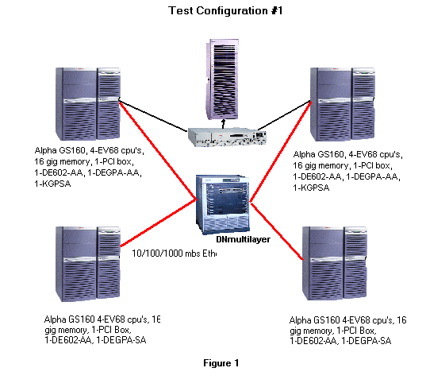

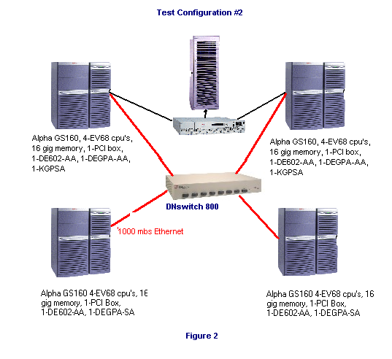

Success Criteria

The success of this system verification was based on 2 major milestones. First, the switches had to boot and configure an OpenVMS cluster consisting of 4 nodes with no measurable loss of LAN packets, and second, each switch had to pass MSCP served I/O with no serious performance impact on I/O or CPU activity. Measurements were taken using standard OpenVMS performance tools such as Monitor and System Dump Analyzer ( SDA ). Average LAN packet round trip transfer time (RTT) and number of collisions were considered to be important and effective measurements of Cluster traffic. Overall CPU utilization and Kernel mode CPU time are also important in cluster performance. If a large amount of Kernel mode CPU time is spent doing cluster overhead activity it could quickly degrade overall system and cluster performance.

Test Results

Results of the tests conducted showed that both switches were able to successfully pass all of the test criteria. The DNmultilayer 1200 was able to configure and run the 4-node OpenVMS Cluster at both 100 Mbs and Gigabit speeds with no discernable performance issues.

The average LAN packet RTT for each of the cluster nodes in 100 Mbs mode was 1400-1500 microseconds for each of the 4 nodes, with the highest recorded average being 4400. LAN traffic RTT for the DNmultilayer using the Gigabit Ethernet paths was significantly lower, on the order of 280-400 microseconds for the same activities indicating a significant performance improvement when using Gigabit Ethernet as the Cluster Interconnect. Overall CPU utilization was extremely low for normal cluster operations, less than 5% of total system activity, and Kernel mode activity was less than 3%, even during heavy volume copy and backup operations between nodes using MSCP access. The packet RTT for the DNswitch 800 was similar to the DNmultilayer Gigabit Ethernet RTT, which is to be expected.

An important configuration requirement that was noted from these tests is that users must verify that the Gigabit Ethernet adapters on the Alpha be set to Full Duplex. This can be done and the >>> prompt using the following command:

>>> SET EWA0_MODE FD

If the Ethernet device is not set to full duplex, the following error message will be received:

PEA0 – Numerous excessive packet losses on LAN Path …..

Test Conclusions

The DNmultilayer family and the DNswitch 800 both proved to be an extremely suitable LAN backbone solution for OpenVMS clusters, especially with Gigabit Ethernet. The DNmultilayer family of switches provides an efficient multi-technology environment, with multiple Gigabit Ethernet and Fast Ethernet ports to allow easy migration from 10/100 based Ethernet clusters to the faster Gigabit environment. The DNswitch 800 makes an excellent Gigabit Ethernet cluster backbone for 4 to 8 node clusters due to its high performance and low cost.

OpenVMS Legacy Network Environment

Digital Equipment Corporation’s Networking Products Group developed the GIGAswitch/FDDI system. A large number of these devices became the backbone for networks as well as the I/O subsystem for OpenVMS Clusters and have been working reliably for years. Today however, with the advent of Gigabit Ethernet, FDDI is slowly falling out of favor and customers are looking to either expand the capabilities of their FDDI environment or looking for ways to integrate FDDI with Fast Ethernet and Gigabit Ethernet. With this in mind, Digital Networks Products chose to define and validate a route for these customers to take.

The typical environment that Digital Networks customers usually have, is an FDDI backbone using 1 or more GIGAswitch/FDDI systems along with 1 or more MultiSwitch 900’s (formerly known as the DECHub 900). Access to the FDDI environment is usually accomplished via DECconnentrators such as the DECconcentrator 900MX or more recently with a VNswitch device such as the VNswitch 900FX. These devices can provide single or dual attach access. Compaq Alpha machines can attach directly to the FDDI backbone using a DEFPA-xx adapter through the GIGAswitch/FDDI system via a DEFGL-xx line card. Since OpenVMS supports Clusters using FDDI as the Cluster Interconnect as well as Fast Ethernet and Gigabit Ethernet, the goal of Digital Networks goal is to allow customers to seamlessly integrate FDDI into a Fast Ethernet and/or Gigabit Ethernet environment.

Proposed Environment

The upgrade of an FDDI environment is actually quite straightforward and can be done in multiple ways. Customers with specific configurations should check with Digital Networks technical support to determine if their specific configuration is supported. To introduce a Gigabit Ethernet cluster interconnect to an existing FDDI cluster, one member of the cluster needs to be equipped with a DEGPA-SA Gigabit Ethernet PCI adapter which is cabled to a VNswitch 900GV or VNswitch 900CG residing in a MultiSwitch 900. This multilayer switch features a single, modular Gigabit Ethernet port (GBIC). The VNswitch product family provides access to the VNbus, a 400 Mbs technology independent bus within the MultiSwitch 900. Connectivity to Gigabit Ethernet is provided via the VNbus through a VNswitch FDDI module such as a VNswitch 900EF. The 900EF is connected to the GIGAswitch/FDDI line card such as the DEFGL which automatically defaults to being a full duplex FDDI connection when connected in a point-to-point configuration. The same DEFGL (or another card) is then connected to the Alpha/VAX systems in the legacy environment. The FDDI adapter in this test scenario was a Single Attached Station ( SAS). The GIGAswitch/FDDI system autoconfigures based upon the input device, however, in the case of configuring an FDDI ring, it is important to configure the VN900EF as an “Entrance into HUB from outside Ring” in the FDDI configuration section. The FDDI node in this configuration did not have direct access to the storage array therefore it utilized MSCP serving to gain access to disks. This scenario would be equal to a satellite node or what is commonly known as a Local Area VMS Cluster or LAN cluster. It was also intended to put an increased load on the switches involved.

Figure 3 shows an example of this configuration.

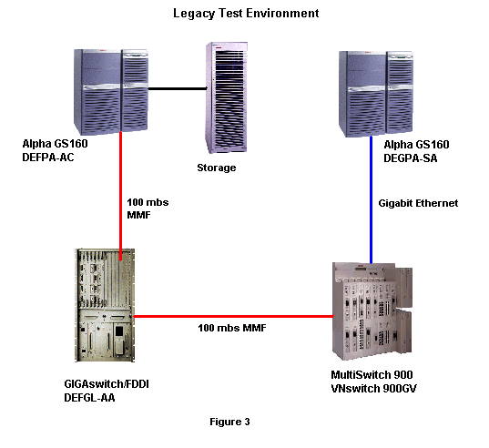

Test Plan

The above configuration was setup within the OpenVMS lab and subjected to the same battery of tests as the DNmultilayer and DNswitch 800.

Test Results

A number of conclusions came from the above test configuration. First, it proved to be a valid configuration with no loss of connection and demonstrated sustainable performance. Packet RTT from the Gigabit node to the FDDI node averaged 3632 microseconds and packet RTT from the FDDI node to the Gigabit node averaged 5228 microseconds. This is slower than the average times for Fast Ethernet most likely due to the number of hops packets had to traverse. Congestion errors in the above configuration were minimal, and were manifested as message retransmits. In all observed cases the number of errors never exceeded 2% of the total packets sent, which we feel is certainly within acceptable limits. There were no Virtual circuit closures reported and the PEdriver statistics showed no errors, so it was determined that these were most likely I/O related errors from the MSCP traffic being handled by the network. Overall network utilization was very low, never reaching more than 5% of total available bandwidth even with the 10 concurrent large disk-to-disk copies taking place.

Test Conclusions

The OpenVMS FDDI to Gigabit Ethernet test proved the hardware solution to be a stable, repeatable solution for those customers wishing to integrate their current FDDI based OpenVMS Cluster systems with Gigabit Ethernet.

